Have created a table named temperature and loaded the data from the temperature.csv file using load command.

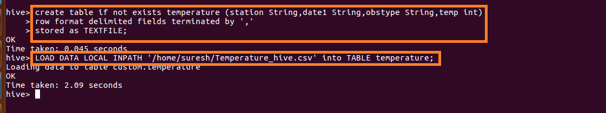

1. Write a hive query to find the minimum temperature observed in a given weather station in a particular year.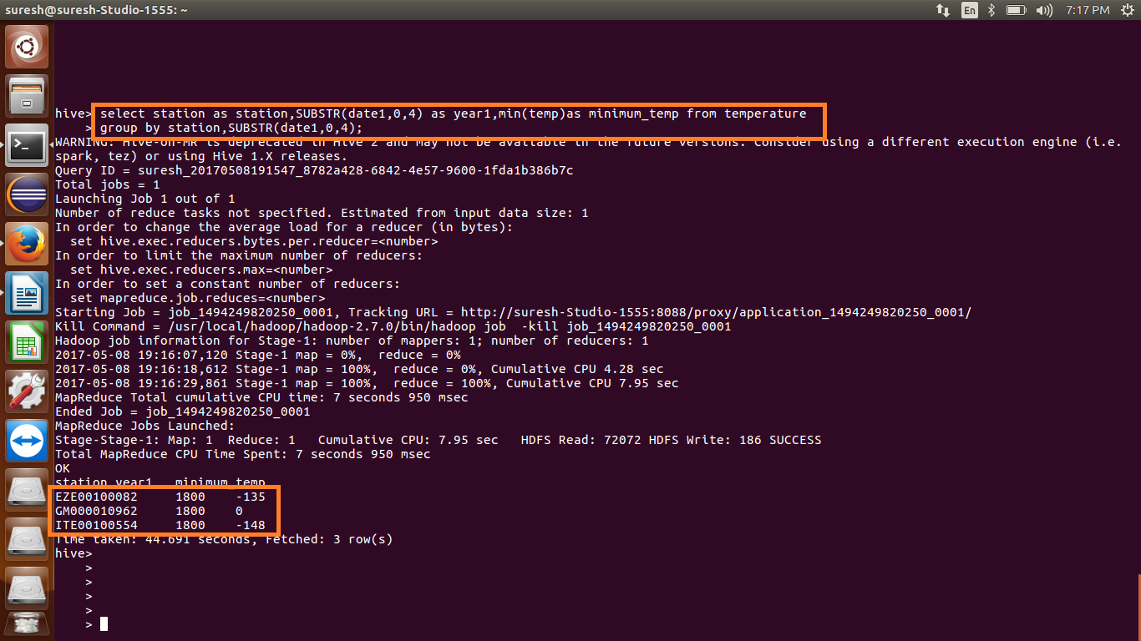

2. Write a hive query to find the maximum temperature observed in a given weather station in a particular year.

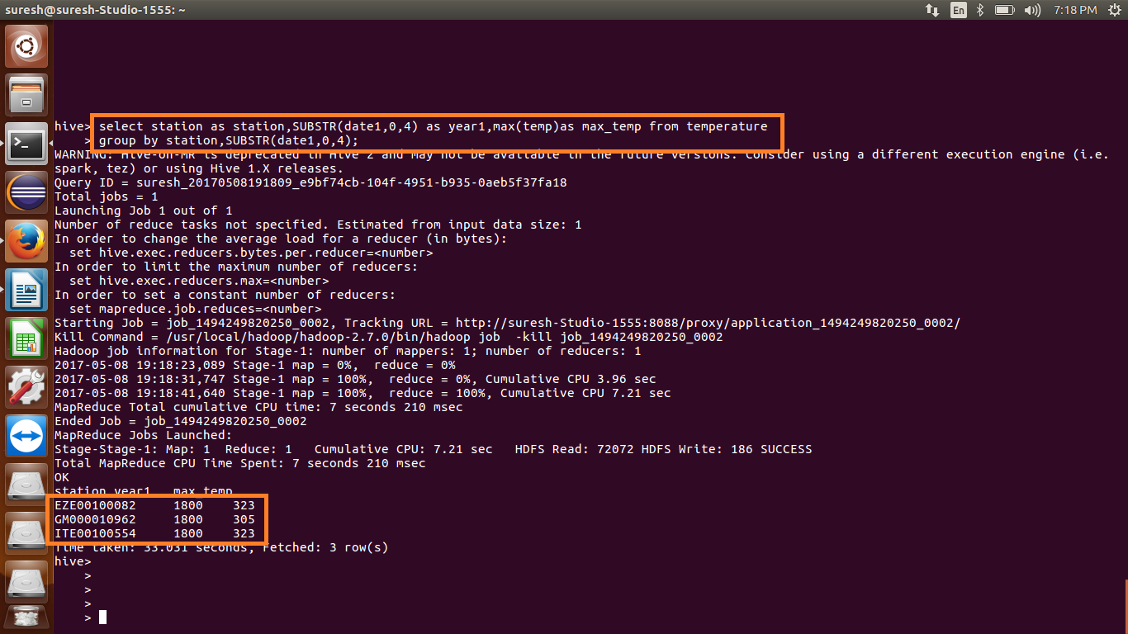

3. Write a hive query to find the number of readings given by each weather station according to the dataset. 